|  |  |
| --- | --- |
| Westbridge | Customer Product Information |

**Chatterton Oak – Dining and Occasional Range**

Congratulations on buying your furniture, you have received a piece of furniture to be proud of. Taking good care of your hardwood furniture ensures its longevity.

CARING FOR YOUR FURNITURE

**General Care**

* Dust frequently with a cloth that attracts rather than scatters dust.
* Dining Tables should be left extended for the first few months to avoid uneven shading.
* Any objects on the surface need to be moved regularly to avoid shading. i.e. Lamps etc...
* Never leave spillages. Remove them immediately with a blotting action.
* For protection against heat, quality tablemats and cloths should always be used. Take care that no area of the plate or dish overhangs the tablemat.
* When writing, a protective mat should be used to protect the surface from marking.
* Furniture will endure most temperatures in the modern home. However, it should be positioned as far away from radiators, direct sunlight or other forms of direct heat sources, as possible.
  + In conservatories care should be taken to ventilate the area to ensure the temperature is not allowed rise to abnormal levels. Failure to do so is likely to result in movements & Splits in the Oak
* Avoid extremes in humidity. This can cause wood to warp and loosen glues. Keep furniture away from air conditioning units.
* The Furniture should not be used for sitting or standing on. (With the obvious exception of sitting on chairs)
* It is always advisable to level furniture when placing it. This will ensure doors are level and also removes undue pressures on joints.
* Never drag furniture - always lift it. **(NB Extending Tables Should be Lifted by the Frame not the Table Top)**

**Metal Handles and Fittings.**

Metal polish should not be used as the fittings have their own protective lacquer to prevent tarnishing.

**Lacquered wood.**

A gentle wipe with a lint free cleaning cloth, in the direction of the grain, is all that is required to maintain the appearance of the lacquered wood.

**Other General Characteristics Of This Range**

* Made from Solid Wood and Veneers selected for their natural beauty. Wood is a unique product, and as such no two sections of the furniture are identical in Grain, Knots, Pattern or colour.

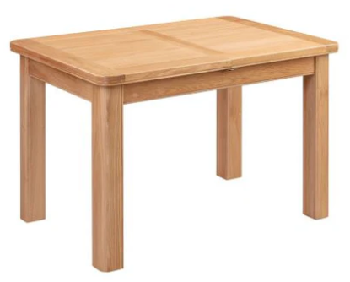Chatterton Oak Range

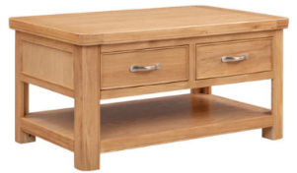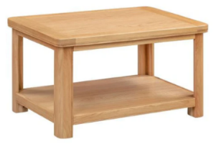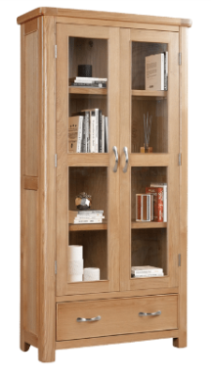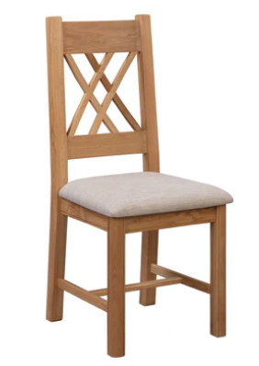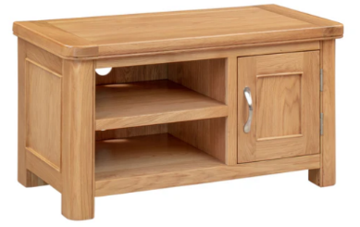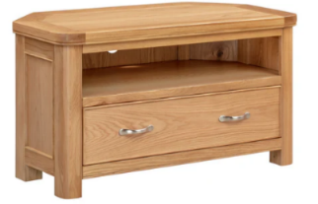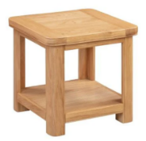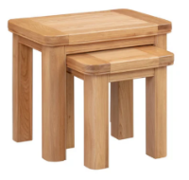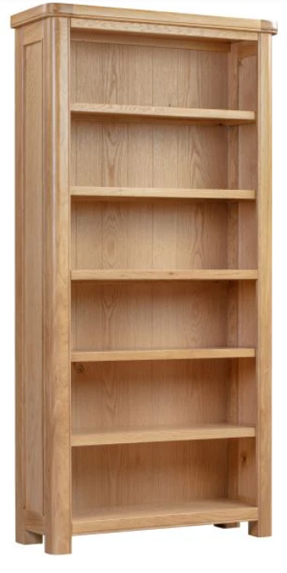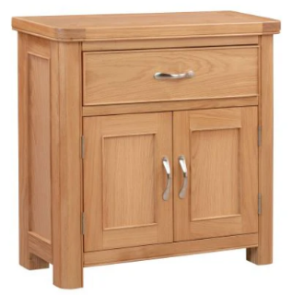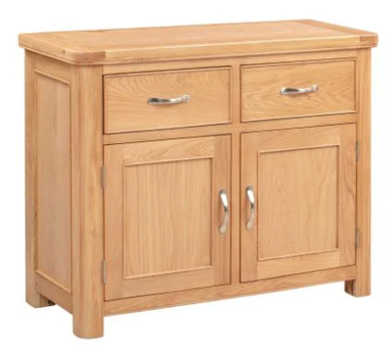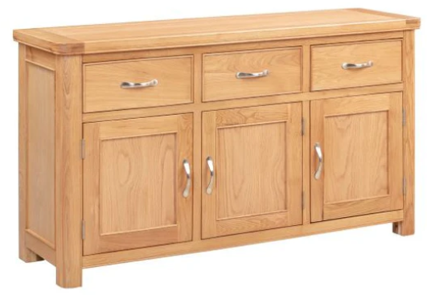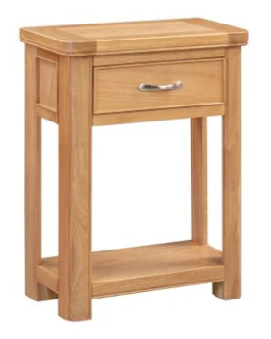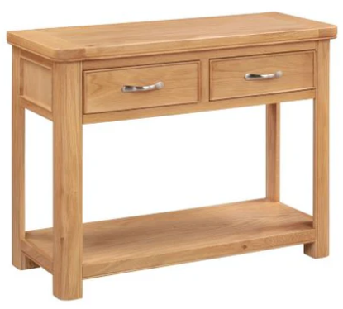

**120cm Extending Dining Table**

**W120/153 x D80 x H78cm**

**Console Table with Drawers**

**W100 x D42 x H80cm**

**Coffee Table with Drawers**

**W100 x D60 x H50cm**

**Corner TV Unit**

**W102 x D51 x H56cm**

**Lamp Table**

**W50 x D50 x H50cm**

**Display Cabinet**

**W90 x D37 x H180**

**Standard Coffee Table**

**W90 x D60 x H50cm**

**Dining Chair**

**W45 x D45 x H105**

**3 Door Sideboard   
W150 x D44 x H86cm**

**2 Door Sideboard  
W106 x D44 x H86cm**

**Compact Sideboard  
W80 x D32 x H80cm**

**Small TV Unit**

**W90 x D44 x H50cm**

**Nest of 2 Tables**

**W58 x D38 x H50cm**

**Oval Extending Dining Table**

**W180/230 x D100 x H79cm**

**180cm Bookcase**

**W90 x D32 x H180cm**

**Small Console Table**

**W60 x D30 x H75cm**