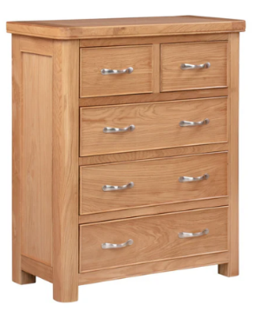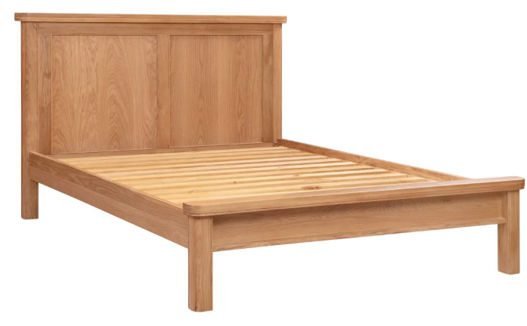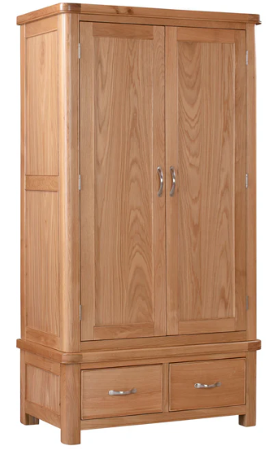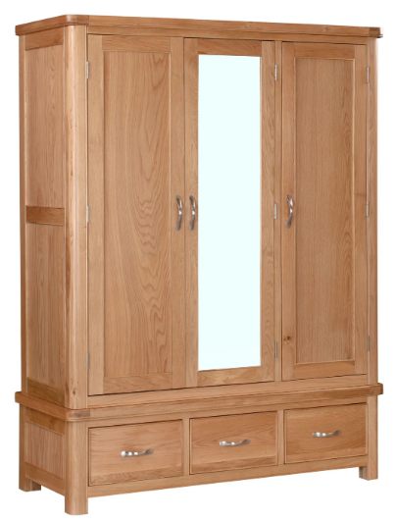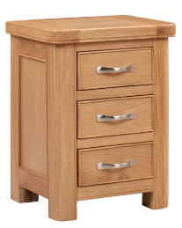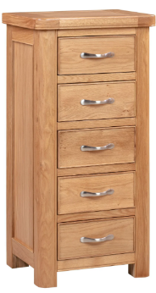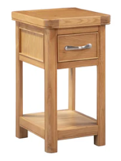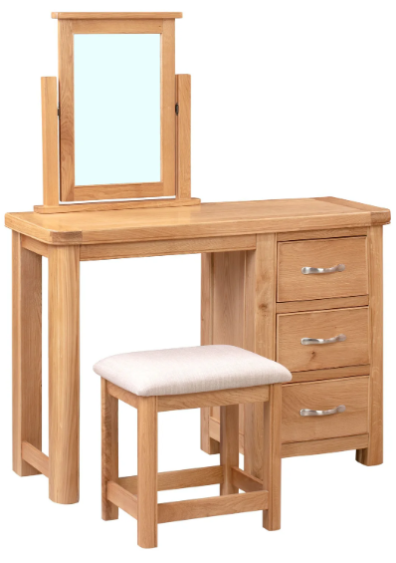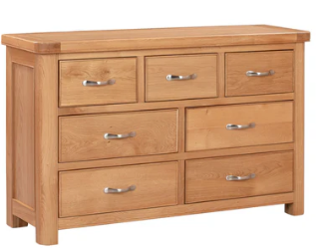**Chatterton Oak Bedroom**

**4ft6 (Double) Bedstead – W209 x D154 x H105cm**

**5ft (King) Bedstead – W219 x D169 x H105cm**

**2 over 3 Chest of Drawers**

**W85 x D40 x H100cm**

**Double Wardrobe with 2 Drawers**

**W102 x D57 x H191cm**

**Triple Wardrobe**

**W146 x D57 x H191cm**

**Dressing Table Set**

**W110 x D40 x H79cm**

**Large Bedside Cabinet**

**W45 x D38 x H60cm**

**Small Bedside Cabinet**

**W34 x D38 x H60cm**

**Tall Chest with 5 Drawers**

**W50 x D40 x H102cm**

**3 over 4 Chest of Drawers**

**W125 x D40 x H79cm**

|  |  |
| --- | --- |
| Westbridge | Customer Product Information |

**Chatterton Oak Bedroom – Care guide**

**Westbridge Quality Furniture Ltd**

Congratulations on buying your furniture, you have received a piece of furniture to be proud of. Taking good care of your hardwood furniture ensures its longevity.

CARING FOR YOUR FURNITURE

**General Care**

* Dust frequently with a cloth that attracts rather than scatters dust.
* Dining Tables should be left extended for the first few months to avoid uneven shading.
* Any objects on the surface need to be moved regularly to avoid shading. i.e. Lamps etc...
* Never leave spillages. Remove them immediately with a blotting action.
* For protection against heat, quality tablemats and cloths should always be used. Take care that no area of the plate or dish overhangs the tablemat.
* When writing, a protective mat should be used to protect the surface from marking.
* Furniture will endure most temperatures in the modern home. However it should be positioned as far away from radiators, direct sunlight or other forms of direct heat sources, as possible.
  + In conservatories care should be taken to ventilate the area to ensure the temperature is not allowed rise to abnormal levels. Failure to do so is likely to result in movements & Splits in the Oak
* Avoid extremes in humidity. This can cause wood to warp and loosen glues. Keep furniture away from air conditioning units.
* The Furniture should not be used for sitting or standing on. (With the obvious exception of sitting on chairs)
* It is always advisable to level furniture when placing it. This will ensure doors are level and also removes undue pressures on joints.
* Never drag furniture - always lift it. **(NB Extending Tables Should be Lifted by the Frame not the Table Top)**

**Metal Handles and Fittings.**

Metal polish should not be used as the fittings have their own protective lacquer to prevent tarnishing.

**Lacquered Wood.**

A gentle wipe with a lint free cleaning cloth, in the direction of the grain, is all that is required to maintain the appearance of the lacquered wood.

**Other General Characteristics.**

* Made from Solid Wood and Veneers selected for their natural beauty. Wood is a unique product, and as such no two sections of the furniture are identical in Grain, Knots, Pattern or colour.