Oslo Bedroom Range
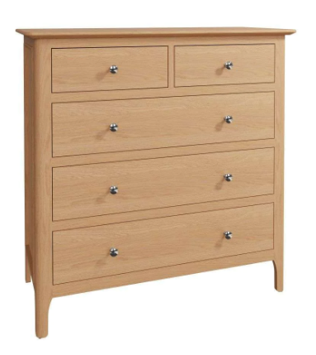

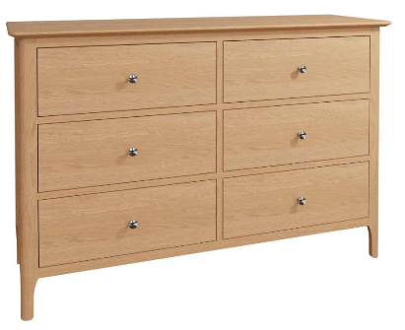
Single 3ft W106 x D203.5 xH110
Double 4ft6 W150 x D203.5 x H110cm
King 5ft W165x D213.5 xH110cm
2 over 3 Chest
W100 x D42 x H95
6 Drawer Chest
W130 x D42 x H85
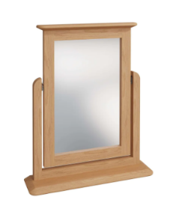


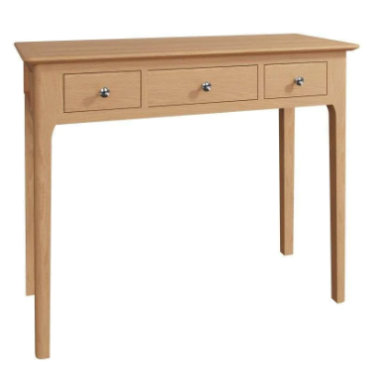
Trinket Mirror
W50 x D12 x H60
3 Door Wardrobe
W145 x D56 x H195
2 Door Wardrobe
W110 x D56 x H195
Dressing Table
W100 x D42 x H80

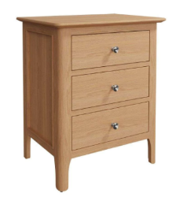
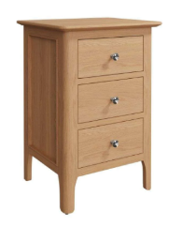
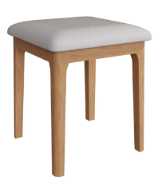
Stool
W42 x D42 x H48
Small Bedside
W38 x D32 x H55
Large Bedside
W45 x D38 x H65

Westbridge | Customer Product Information

Oslo Bedroom Range this is a range name Specific to Westbridge Furniture Designs Ltd
Congratulations on buying your furniture, you have received a piece of furniture to be proud of. Taking good care of your furniture ensures its longevity.

CARING FOR YOUR FURNITURE
Oslo Wooden Surfaces:

- All the products have been lovingly crafted from several wood materials including natural wood, veneers and painted MDF all of which are produced from sustainable sources to minimise impact on the environment.
- Wood is a natural product; therefore, grain patterns such as knots and small movements are completely normal and add to the individuality and character of each piece.
- Sunlight can cause fading to the finish, avoid positioning your items in front of a window or direct sunlight.
- Moisture can cause damage and bubbling. If a spill occurs, please mop it up with a dry cloth and ensure all liquid is absorbed
(We also recommend using coasters and placemats)
- Heat will cause damage, avoid placing your item close to radiators and fireplaces, never place dishes from the oven on the top.

Cleaning:

- All our furniture is finished in either a lacquer or paint to protect the wood and let its natural beauty shine through.
- Items that have a lacquered or painted finish need dusting regularly to prevent dirt or debris build up
- For stubborn dirt, use a soft damp cloth.
- Please do not use an abrasive material, or silicone based cleaners.
- Never use furniture polish or cleaners
- Wipe with a damp cloth regularly to maintain cleanliness.

Oslo Stool:

- The upholstered chair surfaces can be cleaned with a vacuum cleaner or with a soft brush.
- Do not use cleaning agents which contain abrasive substances or solvents.
- Chairs need to be placed on a level surface to ensure stability when sitting.
- The chair is only intended for indoor use.
- The chair can be used by one person only. Do not stand on the chairs.
- At least every 4 months the bolts should be checked to make sure that they are tight.

