# Camden Dining and Occasional Range

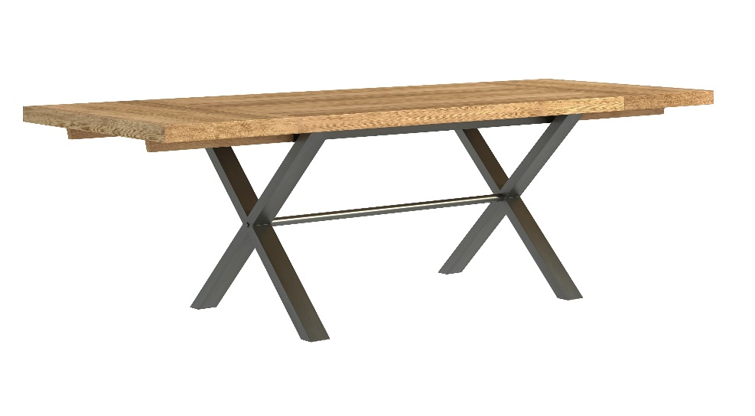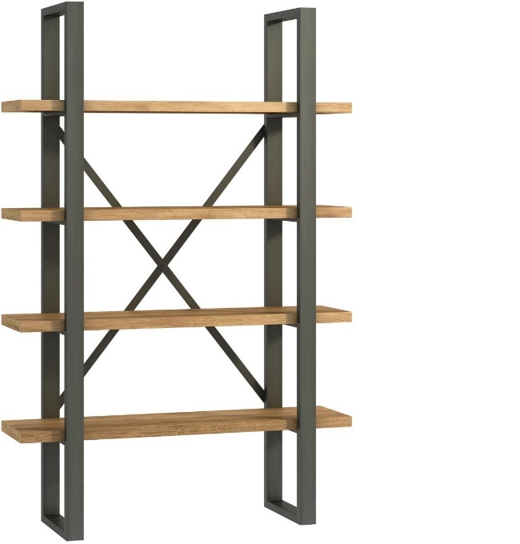

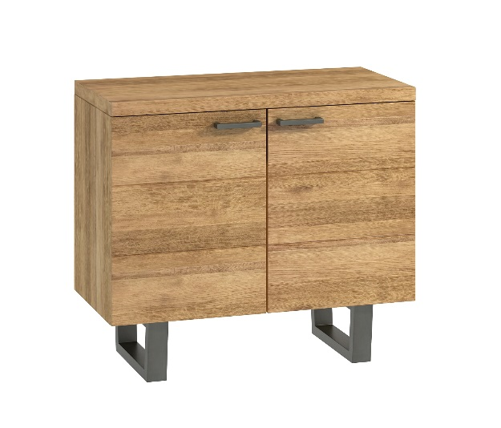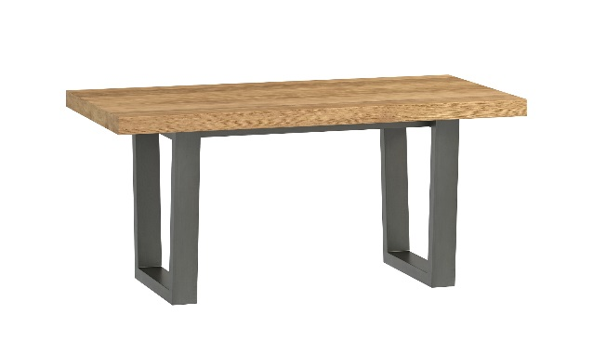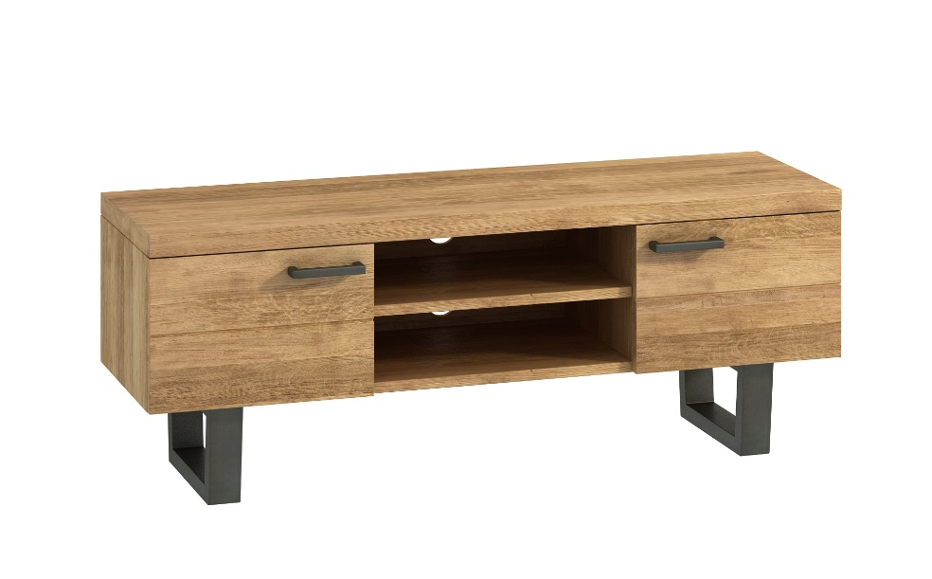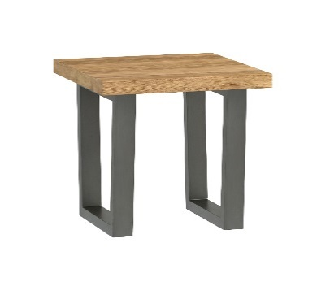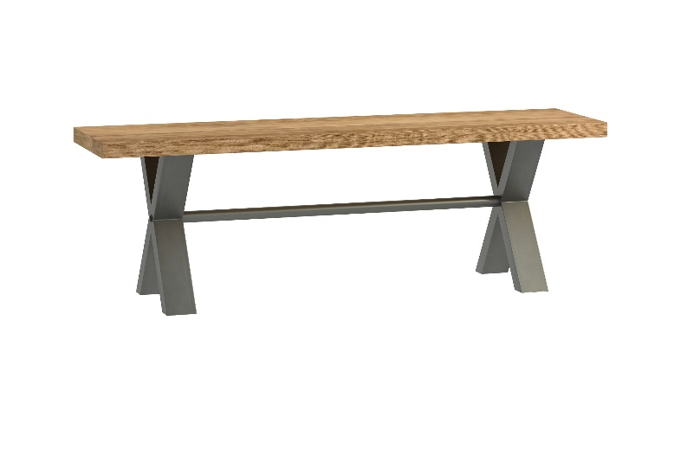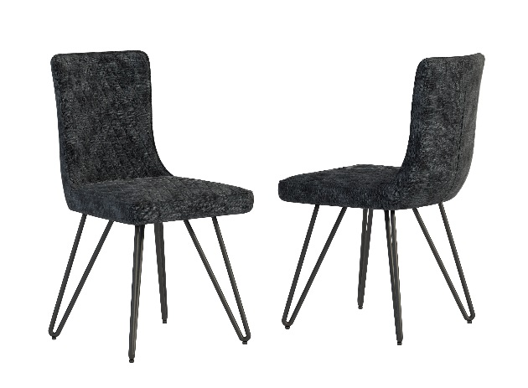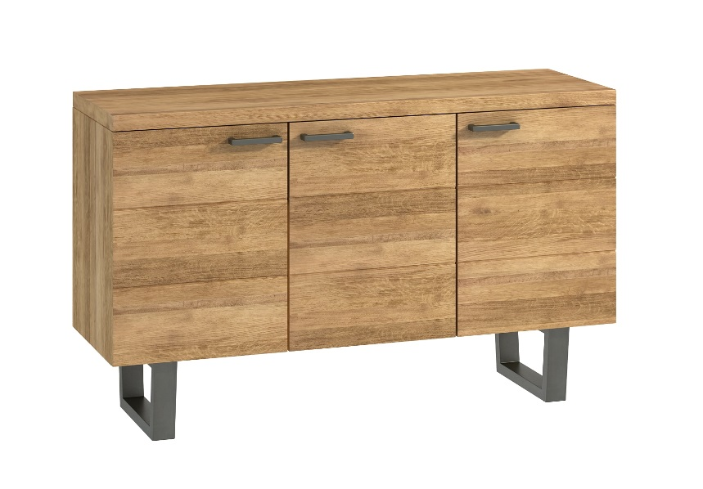

Small Bench W140xD35xH45cm

Large Bench W180xD35xH45cm

Chair

W46xD63xH91cm

3 Door Sideboard

W140xD45xH85cm

Coffee Table

W100xD50xH45cm

Lamp Table

W50xD50xH45cm

Low TV Unit

W132xD40xH50cm

2 Door Sideboard

W94xD45xH82cm

Shelf Unit

W120xD35xH200cm

Small Table W150xD95xH76cm

Large Table W190xD95xH76cm

Extensions can be purchased separately W50x95cm