|  |  |
| --- | --- |
| Westbridge | Customer Product Information |

**Foxley - Painted Living, Dining, Occasional**

**& Bedroom**

**Westbridge Furniture Designs Ltd**

Congratulations on buying your furniture, you have received a piece of furniture to be proud of. Taking good care of your hardwood furniture ensures its longevity.

CARING FOR YOUR FURNITURE

**General Care**

* Dust frequently with a cloth that attracts rather than scatters dust.
* Dining Tables should be left extended for the first few months to avoid uneven shading.
* Any objects on the surface need to be moved regularly to avoid shading. i.e. Lamps etc...
* Never leave spillages. Remove them immediately with a blotting action.
* For protection against heat, quality tablemats and cloths should always be used. Take care that no area of the plate or dish overhangs the tablemat.
* When writing, a protective mat should be used to protect the surface from marking.
* Furniture will endure most temperatures in the modern home. However it should be positioned as far away from radiators, direct sunlight or other forms of direct heat sources, as possible.
  + In conservatories care should be taken to ventilate the area to ensure the temperature is not allowed rise to abnormal levels. Failure to do so is likely to result in movements & Splits in the Oak
* Avoid extremes in humidity. This can cause wood to warp and loosen glues. Keep furniture away from air conditioning units.
* The Furniture should not be used for sitting or standing on. (With the obvious exception of sitting on chairs)
* It is always advisable to level furniture when placing it. This will ensure doors are level and also removes undue pressures on joints.
* Never drag furniture - always lift it. **(NB Extending Tables Should be Lifted by the Frame not the Table Top)**

**Metal Handles and Fittings.**

- Metal polish should not be used as the fittings have their own protective lacquer to prevent tarnishing.

**Painted Finishes.**

- Minor Blemishes or runs in the Painted finishes are unavoidable and therefore is an inherent part of the characteristics of this range. Hairline cracks on the joints of timber are unavoidable due to movements in the timber frame. Use only a slightly dampened cloth to clean. Cleaning products may damage the painted finish.

**Lacquered Wood Tops.**

- A gentle wipe with a lint free cleaning cloth, in the direction of the grain, is all that is required to maintain the appearance of the lacquered wood.

**Other General Characteristics.**

- Made from Solid Wood and Veneers selected for their natural beauty. Wood is a unique product, and as such no two sections of the furniture are identical in Grain, Knots, Pattern or colour.

|  |  |
| --- | --- |
| Westbridge | Customer Product Information |

**Foxley Painted Living Collection**

**

**Foxley Compact Sideboard**   
W80 x D32 x H80cm

**Foxley 2 Door Sideboard**   
W96 x D35 x H77cm

**Foxley 3 Door Sideboard**   
W137 x D43 x H85cm

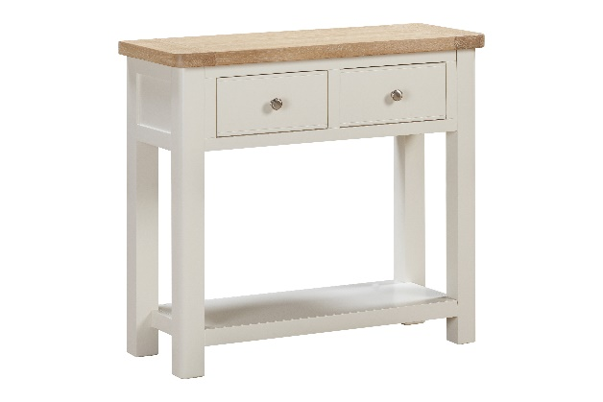

**Foxley 90cm Wide Bookcase**   
W90 x D30 x H90cm

**Foxley 2 Drawer Console Table**   
W85 x D35 x H77cm

**Foxley Nest of 2 Tables**   
W55 x D40 x H50cm

**Foxley 180cm Tall Bookcase**   
W90 x D30 x H180cm

**Foxley 2 Drawer Coffee Table**   
W100 x D60 x H50cm

**Foxley Lamp Table**   
W50 x D50 x H50cm

**Foxley Corner TV Unit**   
W100 x D45 x H50cm

**Foxley Large TV Unit** W120 x D45 x H50cm