|  |  |
| --- | --- |
| Westbridge | Customer Product Information |

Carnforth Oak Dining and Occasional  **this is a range name particular to Westbridge Furniture Designs Ltd**

Congratulations on buying your furniture, you have received a piece of furniture to be proud of. Taking good care of your hardwood furniture ensures its longevity.

CARING FOR YOUR FURNITURE

**General Care**

* Dust frequently with a cloth that attracts rather than scatters dust.
* Dining Tables should be left extended for the first few months to avoid uneven shading.
* Any objects on the surface need to be moved regularly to avoid shading. i.e. Lamps etc...
* Never leave spillages. Remove them immediately with a blotting action.
* For protection against heat, quality tablemats and cloths should always be used. Take care that no area of the plate or dish overhangs the tablemat.
* When writing, a protective mat should be used to protect the surface from marking.
* Furniture will endure most temperatures in the modern home. However it should be positioned as far away from radiators, direct sunlight or other forms of direct heat sources, as possible.
* Avoid extremes in humidity. This can cause wood to warp and loosen glues. Keep furniture away from air conditioning units.
* The Furniture should not be used for sitting or standing on. (With the obvious exception of sitting on chairs)
* It is always advisable to level furniture when placing it. This will ensure doors are level and also removes undue pressures on joints.
* Never drag furniture - always lift it. **(NB Extending Tables Should be Lifted by the Frame not the Table Top)**

**Metal Handles and Fittings.** Metal polish should not be used as the fittings have their own protective lacquer to prevent tarnishing.

**Lacquered wood.** A gentle wipe with a lint free cleaning cloth, in the direction of the grain, is all that is required to maintain the appearance of the lacquered wood. A Coat of Beeswax should be applied to the wood a couple of times a year to maintain lustre. A soft furniture brush designed for buffing wax polish is recommended.

**Other General Characteristics Of This Range**

* Made from Solid Oak and Veneers selected for their natural beauty. Wood is a unique product, and as such no two sections of the furniture are identical in Grain, Knots, Pattern or colour.
* This range features expansion joints that may open and close due to the heat and humidity of their environment. This is an important part of the design and will help protect the furniture as it naturally expands and contracts.

# Carnforth Oak Dining and Occasional

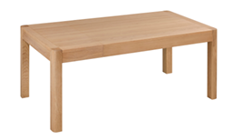

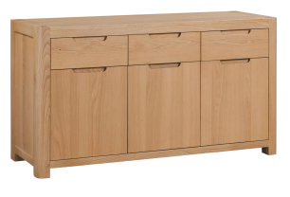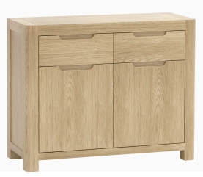

**Extending Dining Table  
W140/180 x D90 x 78cm**

**3 Drawer Sideboard W150 x D40 x H80cm**

**2 Drawer Sideboard W100 x D40 x H80cm**

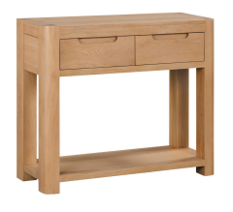

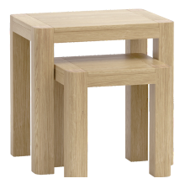

**Nest of Tables  
W55 x D40 x H50cm**

**Small Console Table  
W90 x D30 x H75cm**

**Corner TV Unit  
W105 x D55 x H55cm**

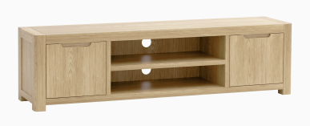

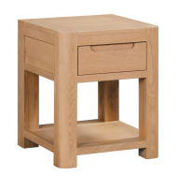

**Dining Chair  
W46 x D58 x H98cm**

**Wide TV Unit  
W180 x D40 x H50cm**

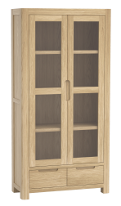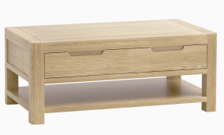

**Lamp Table  
W45 x D45 x H55cm**

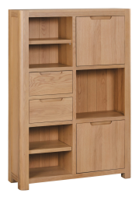

**Coffee Table   
W110 x D60 x H45cm**

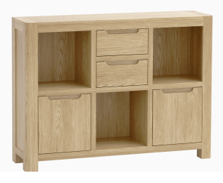

**Display Cabinet W90 x D37 x 180cm**

**High Display Cabinet  
W100 x D30 x H145cm**

**Low Display Unit W115 x D30 x H85**